AEM – Brackets Extension

Before this tool, we were using VLT tool but this can be a great alternative of vault in AEM.

**Benefits over Vault:**

* Automatic Syncing
* List each and every file you have changed in brackets, so that unnecessary changes won’t go.
* Easy to use console

**Steps involved in installation of Brackets AEM Extension:**

* The AEM Brackets Extension supports Brackets version 1.0 or greater. Download the Latest Brackets from <http://brackets.io/>

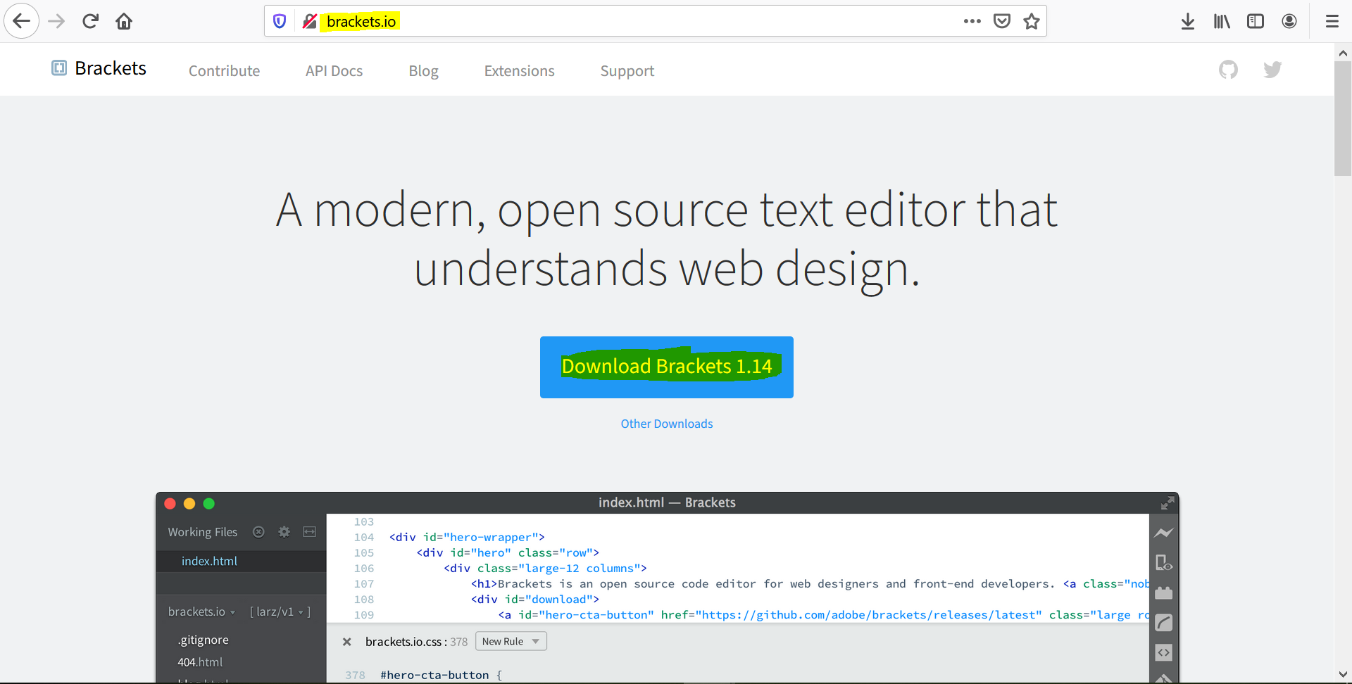

* Add AEM Brackets Extension
  + Go to File-> Extension Manager

(or) you can click on the extension icon present on the right side.



* + Search AEM Brackets Extension in the Search Bar.
  + Install the software

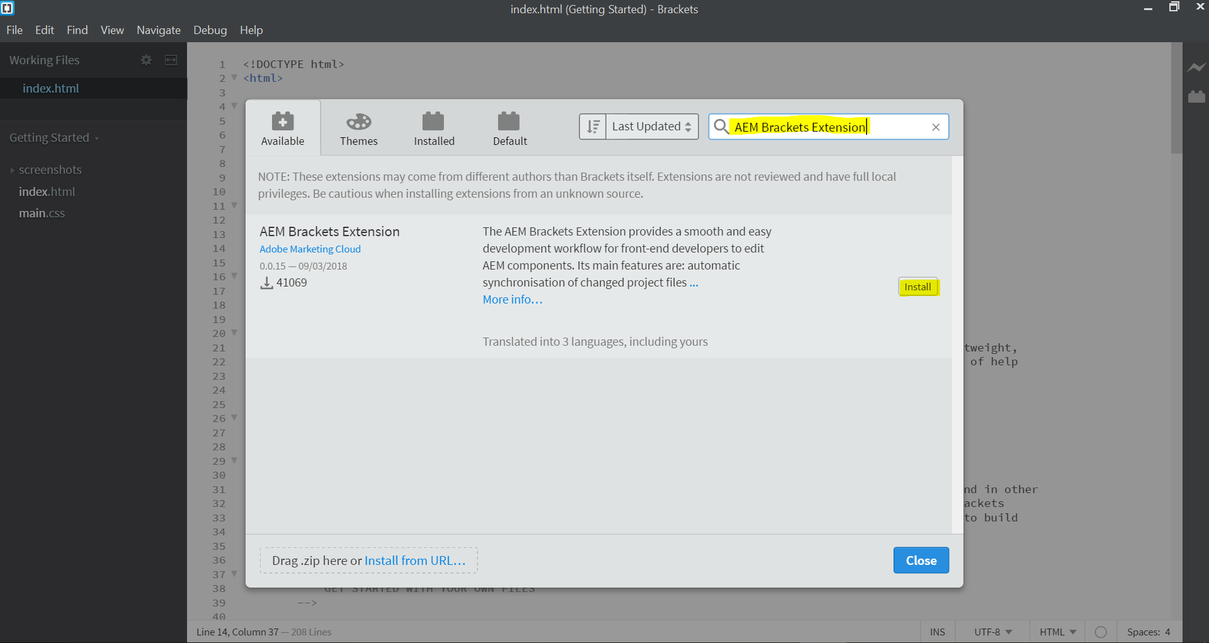

**Important to Note:**

* Sometimes install become failed so you can use “**install from URL** “and give the [github](https://github.com/Adobe-Marketing-Cloud/aem-brackets-extension) path here.

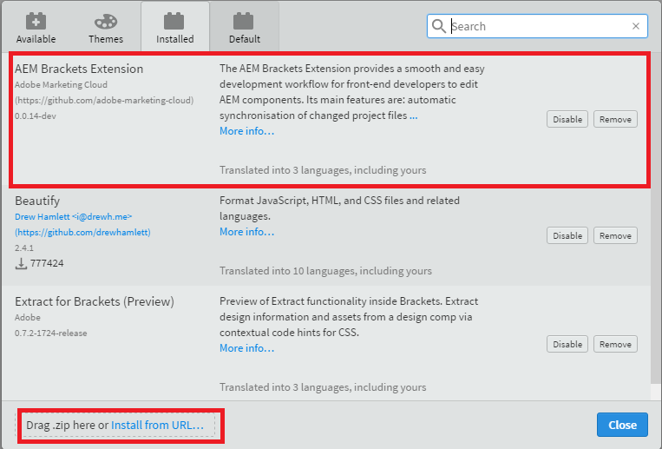

* If this also doesn’t work, you can download the zip from [github](https://github.com/Adobe-Marketing-Cloud/aem-brackets-extension) and put it on “**drag zip here**”.
* After the installation of extension, you can open content package folder (jcr_root) of the project in brackets.

**Connect Brackets with Server:**

In order to synchronize your content to and from development AEM instance, you need to define your project Settings.

* + Go to AEM->Project Settings
  + Add configurations like this:

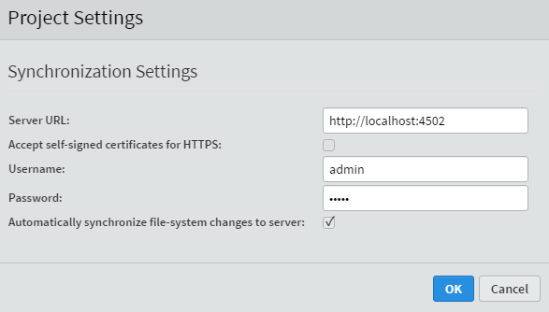

This is automatically generated “**brackets.json**” file in brackets which contains all the configurations, added in the above dialog.

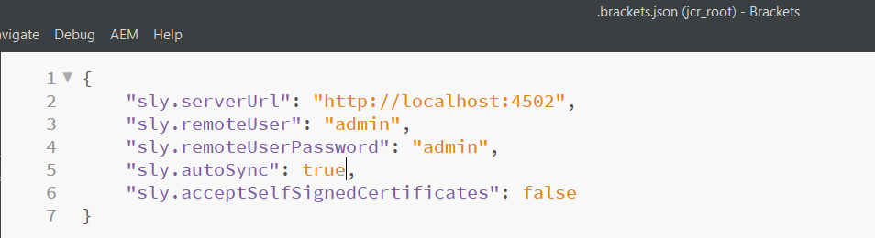

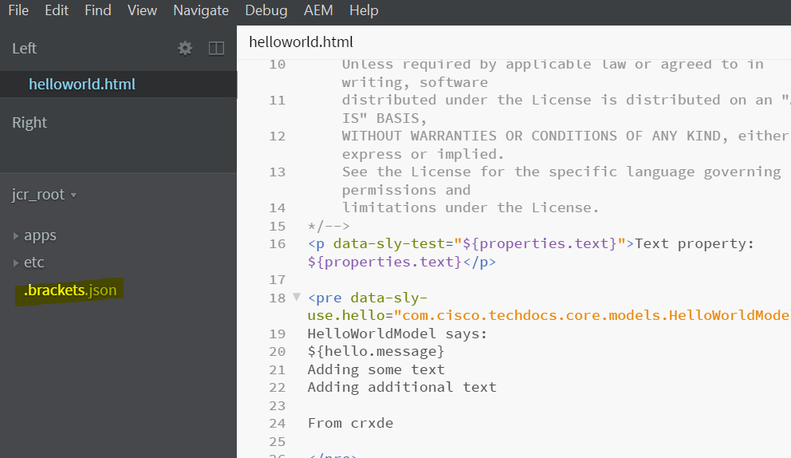

**Advantages of AEM Brackets Extension:**

1. **Synchronization Content:**

The AEM Brackets Extension provides synchronization based on the rules written in filter.xml. So filter.xml play a very important role in syncing the content.

- **Automatic Synchronization of Changed Files:**

This synchronize changes from Brackets editor to AEM but the automatic synchronization is not applicable from AEM instance to brackets editor.

- **Manual Bidirectional Synchronization:**

In the Project Explorer, You can **Export to Server** and **Import from Server** options which right clicking on a file and folder.

Note: Once the changes are made in brackets, and after saving the file. Changes will be automatically exported to crx/de server and we can see that in the results section.

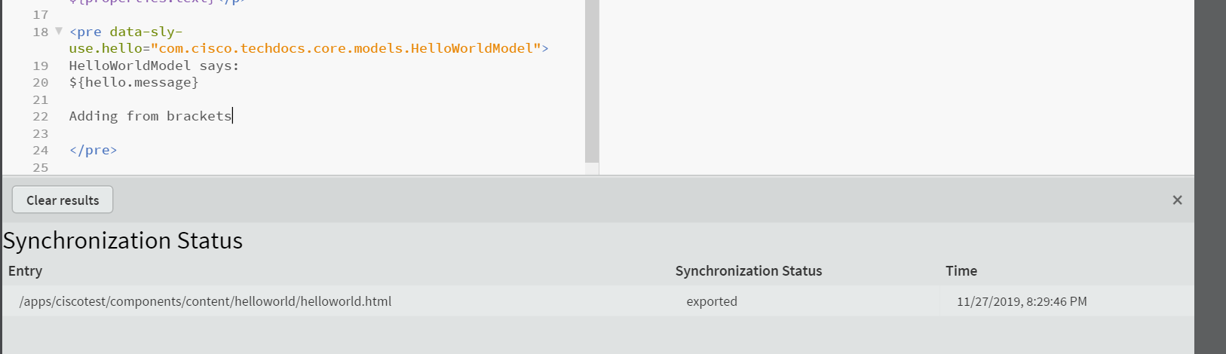

But to get the changes from crx/de to brackets, we need to right click the file or folder and select the option -> Import from server.

Once the import is successful, we see the log like below, with synchronization status as imported (means that the changes are imported to brackets from crx/de server).

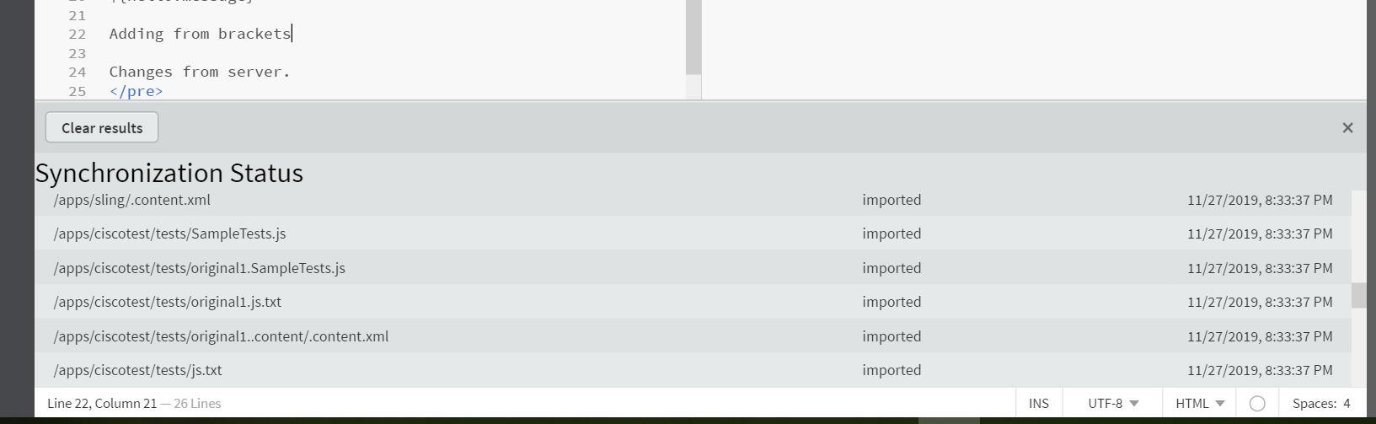

1. **Synchronization Status**: The AEM Bracket Extension provides a notification icon on the right hand side of console, which indicates the status of the synchronization.

Different colors represent different status of synchronization:

**Green:** All data has been synchronized

**Blue**: Data synchronization is in progress.

**Red**: Data is unable to synchronize.

**Yellow**: Some of the files are not synchronized.

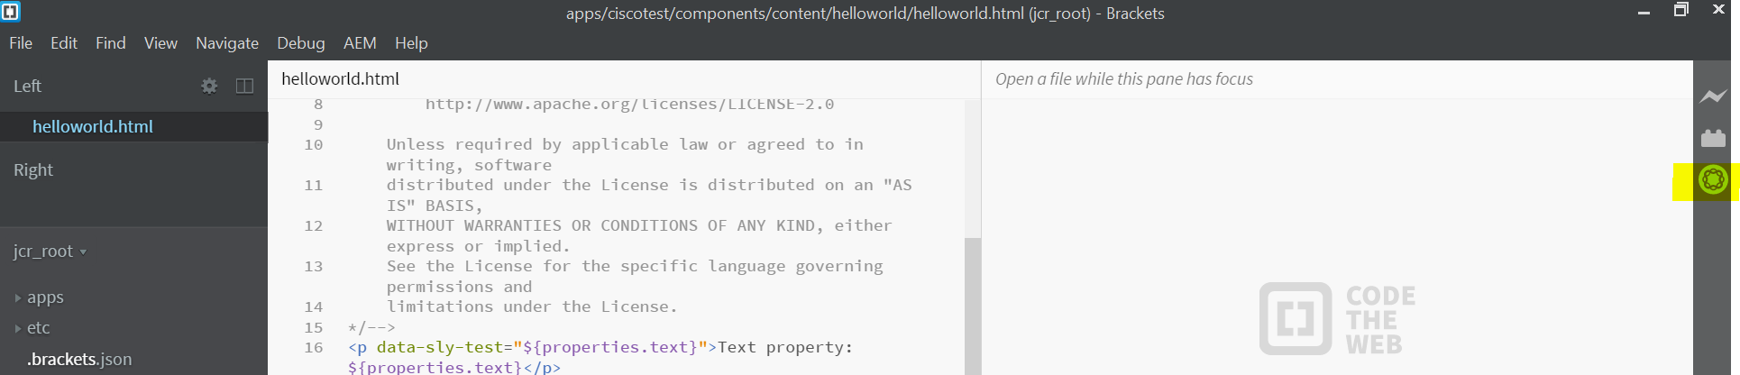

1. The full content package (whole project) can be synchronized by using the options like **Export Content Package** and **Import Content Package** in the **AEM** Menu.
2. The AEM Brackets Extension provides some auto completion options that helps to write “**HTL attributes**” and “**expressions**”.